K-nearest neighbors (KNN)

1.What is accuracy of training and testing data?

*Round to two decimal places*

The accuracy of the train set is 0.93

The accuracy of the test set is 0.90

The accuracy of the test set is 0.80

The accuracy of the train set is 0.78

Answer: The accuracy of the train set is 0.93

The accuracy of the test set is 0.90

2. k-NN algorithm does more computation on test time rather than train time.

No

Yes

Answer: yes

3. Which of the following option is true about KNN algorithm?

It can be used for classification

It can be used for regression

It can be used in both classification and regression

Anser:3

4. Which of the following statement is true about KNN algorithm ?

KNN works well with a small number of input variables.

KNN performs much better if all of the data have the same scale.

k-NN makes assumptions about the functional form of the problem being solved.

Answer:1,2

5. **Decision Boundaries**

The Figure below illustrates decision boundaries for two nearest-neighbour classifiers. Determine which one of the boundaries belongs to the 1-nearest neighbour classifier.

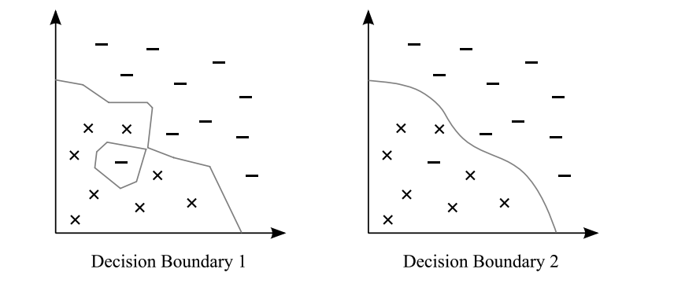

Preview

Decision boundary 1

Decision boundary 2

Answer:1